Cloud Only Data Pipeline Implemetation

- Receives CSV files from the sales team (monthly sales data).
- Stores them in Azure Blob Storage.
- Processes and ingests them into Snowflake using Snowpark (Snowflake’s Python API).
- Transforms the data into structured tables and views.
- Visualizes the data in Power BI for business users.

Sales Team → Azure Blob Storage → Azure Databricks (Snowpark) → Snowflake → Power BI

Phase 1: Setting Up Azure Blob Storage
Step 1: Create a Storage Account
- Sign in to the Azure Portal.
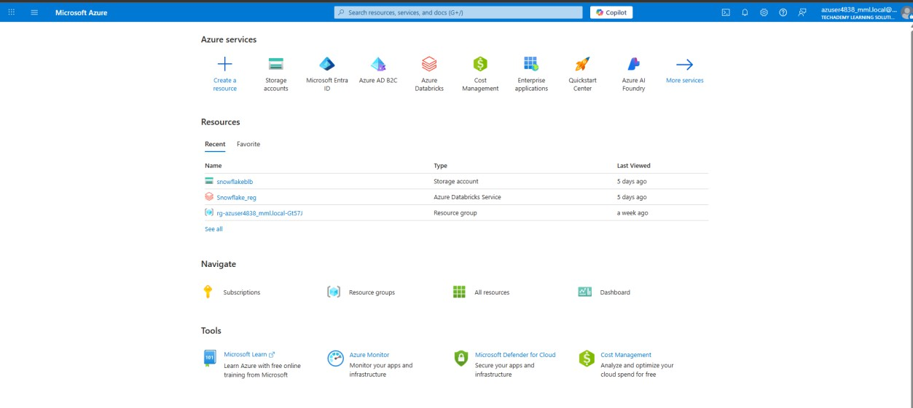
- Click "Create a resource" and search for "Storage account".
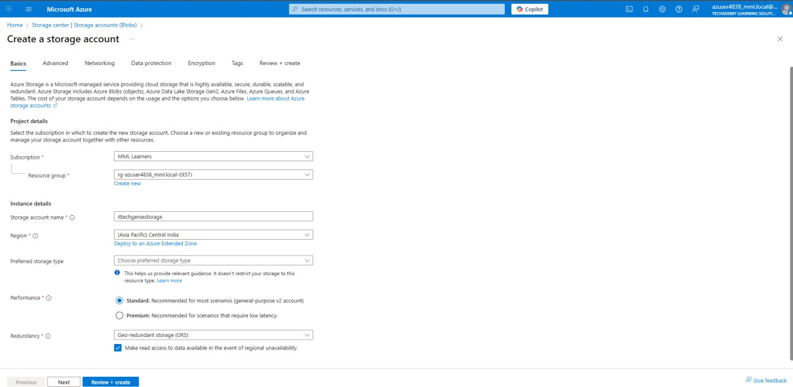
- Choose your subscription and either select an existing resource group or create a new one (e.g., ItTechGenie-RG).
- Set the storage account name (e.g., itgretailstorage) and region (e.g., East US).
- Choose Standard performance and Locally-redundant storage (LRS) for redundancy.
- Click Review + Create, then Create.
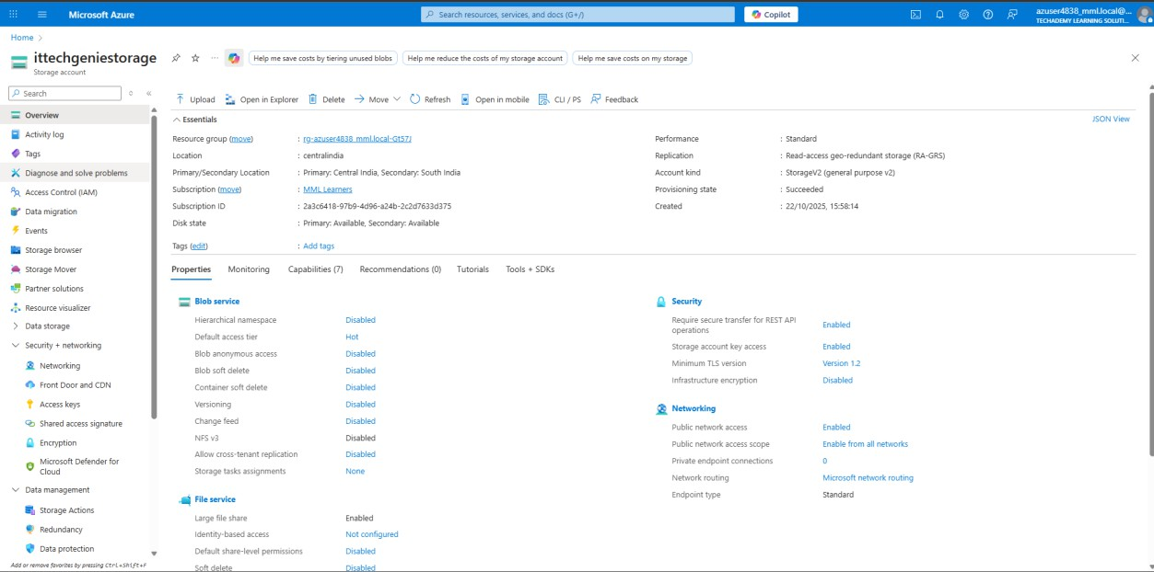

Step 2: Create a Container
- Inside your storage account, go to "Containers".
- Click "+ Container" and name it something like monthly-sales.
- Set the access level to Private.
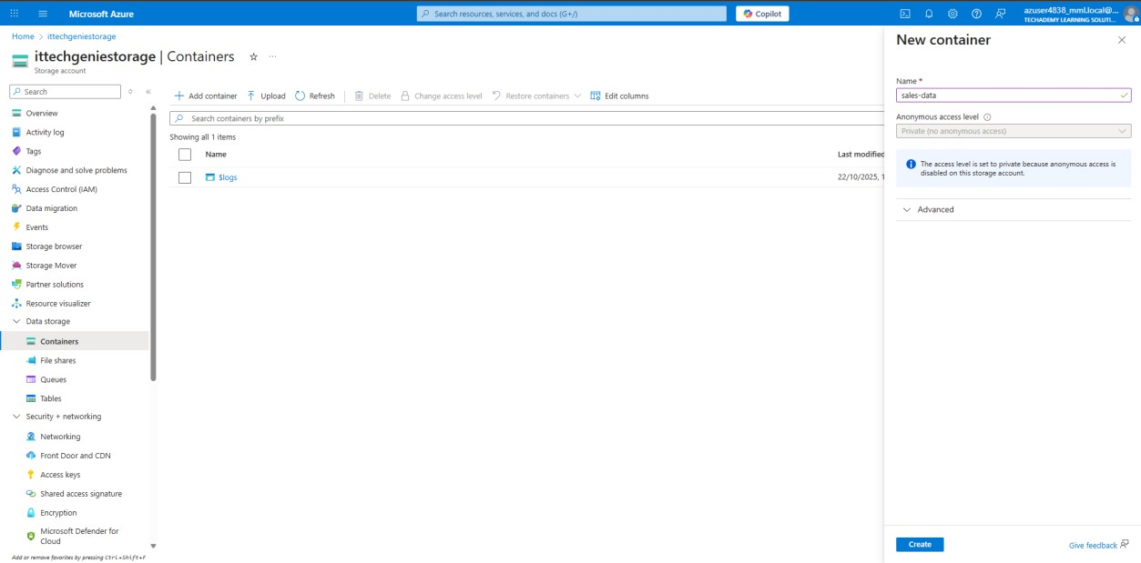
Step 3: Upload the CSV File
Option A: Azure Portal
- Navigate to the monthly-sales container.
- Click Upload, select your .csv file (e.g., sales_october.csv), and upload it.

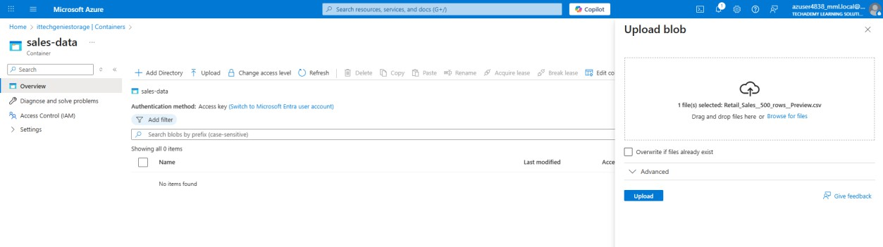
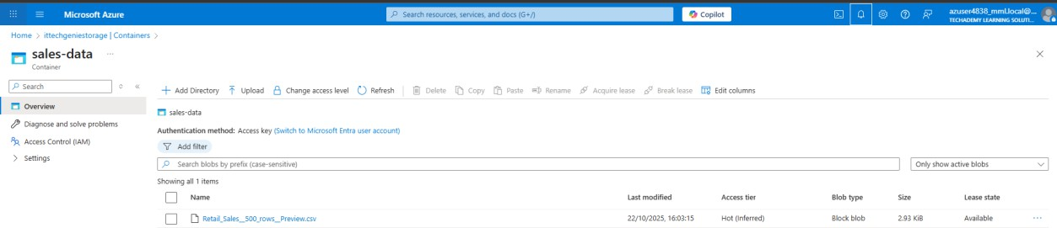

Option B: Azure Cloud Shell
az storage blob upload \
--account-name itgretailstorage \
--container-name monthly-sales \
--name sales_october.csv \
--file sales_october.csv \
--auth-mode login

Phase 2: Provisioning Azure Databricks
Step 1: Create a Databricks Workspace
- In Azure Portal, click Create a resource and search for Azure Databricks.
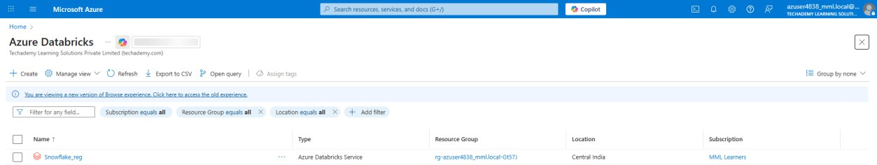
- Set the workspace name (e.g., itgretail-databricks) and region (same as storage).
- Choose the Premium pricing tier.
- Click Review + Create, then Create.
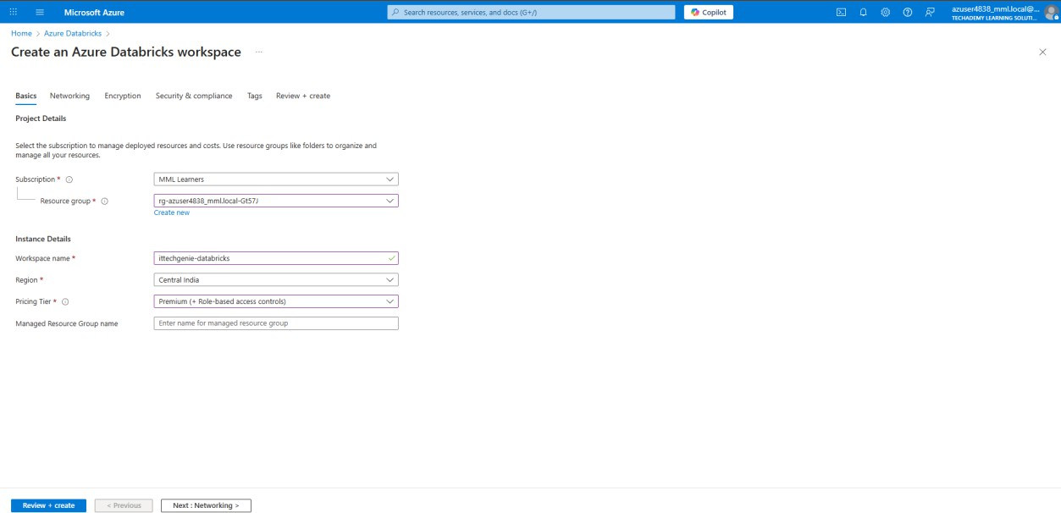

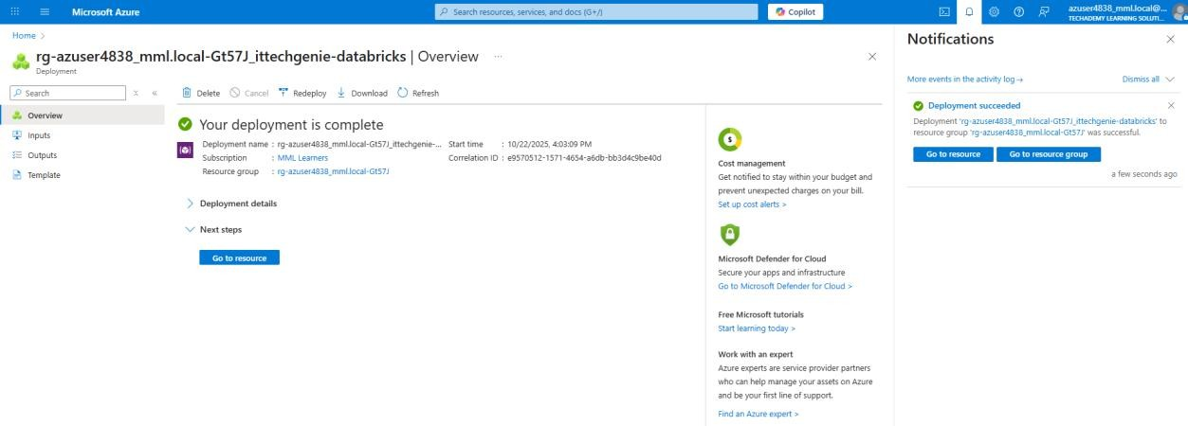

Step 2: Launch and Configure a Cluster
- Open the Databricks workspace.
- Go to Compute and click Create Cluster.
- Configure:
- Name: snowflake-pipeline
- Mode: Single Node
- Runtime: 12.2 LTS
- Node Type: Standard_DS3_v2
- Auto-termination: 30 minutes
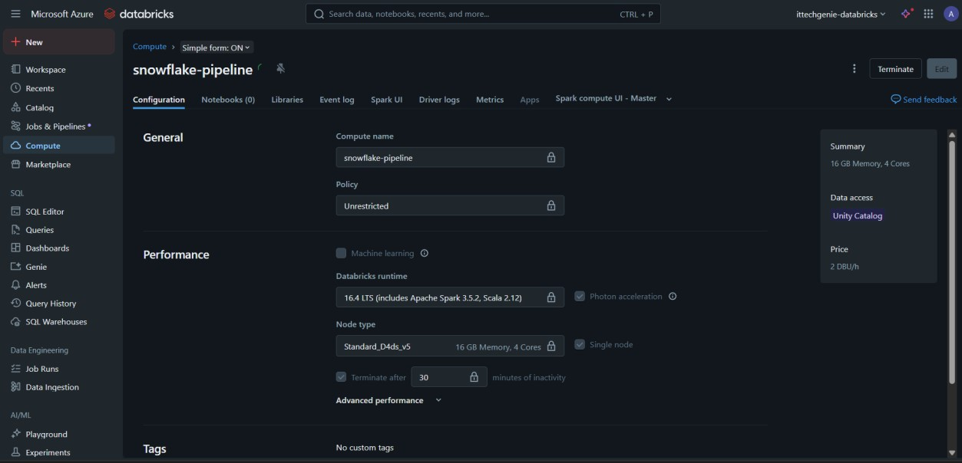

Phase 3: Snowflake Setup
Step 1: Create Snowflake Objects
Run the following SQL in Snowflake

CREATE WAREHOUSE ITG_WAREHOUSE WITH WAREHOUSE_SIZE = XSMALL AUTO_SUSPEND = 300 AUTO_RESUME = TRUE;
CREATE DATABASE ITG_SALES_DB;
CREATE SCHEMA ITG_SALES_DB.RAW;
CREATE SCHEMA ITG_SALES_DB.MODELED;
CREATE SCHEMA ITG_SALES_DB.REPORTING;
CREATE ROLE DATA_ENGINEER;
GRANT USAGE ON WAREHOUSE ITG_WAREHOUSE TO ROLE DATA_ENGINEER;
GRANT ALL ON DATABASE ITG_SALES_DB TO ROLE DATA_ENGINEER;

Step 2: Connect Snowflake to Azure

CREATE STORAGE INTEGRATION azure_sales_integration
TYPE = EXTERNAL_STAGE
STORAGE_PROVIDER = AZURE
ENABLED = TRUE
AZURE_TENANT_ID = '<your-tenant-id>'
STORAGE_ALLOWED_LOCATIONS = ('azure://itgretailstorage.blob.core.windows.net/monthly-sales/');

Then run:

DESC STORAGE INTEGRATION azure_sales_integration;

Use the AZURE_CONSENT_URL to authorize Snowflake to access your Azure storage.
Phase 4: Data Ingestion with Snowpark in Databricks
Step 1: Install Required Libraries
%pip install snowflake-snowpark-python pandas
dbutils.library.restartPython()

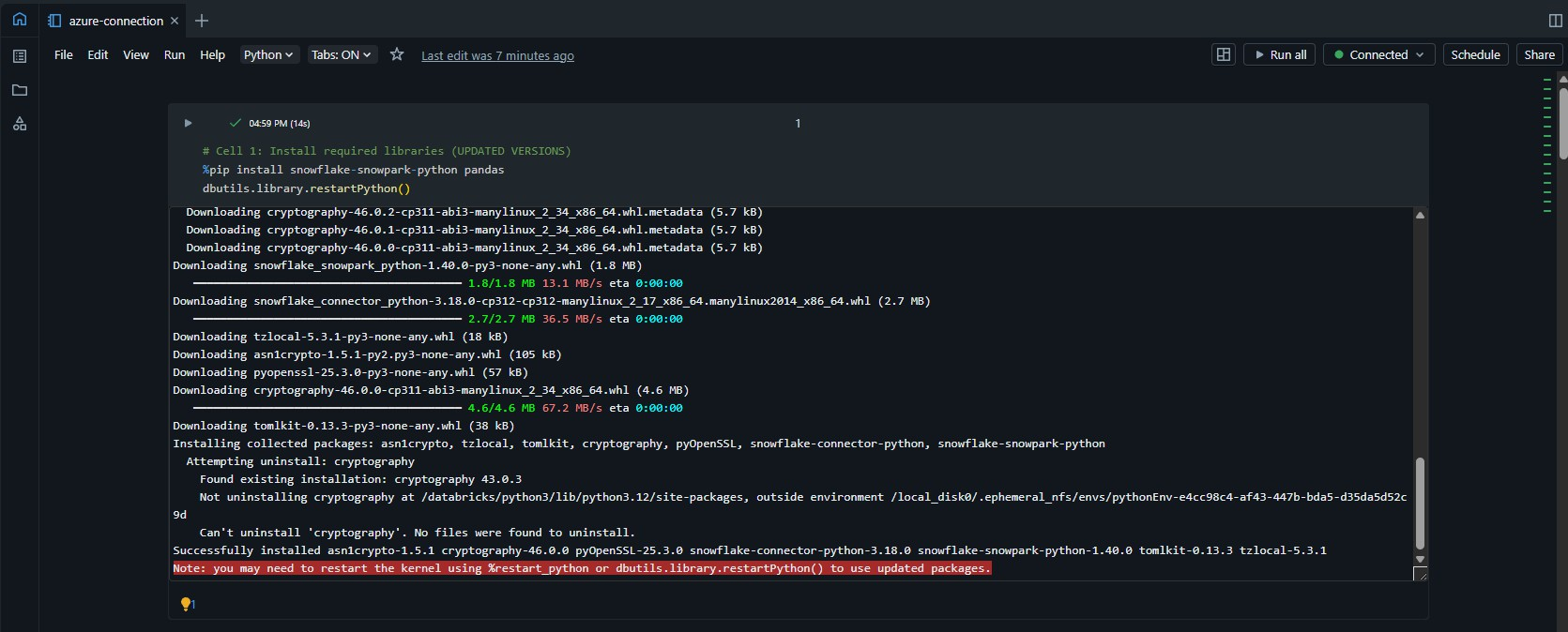

Step 2: Configure Snowflake Connection

from snowflake.snowpark import Session
connection_parameters = {
"account": "<your_account>",
"user": "<your_user>",
"password": "<your_password>",
"role": "ACCOUNTADMIN",
"warehouse": "ITG_WAREHOUSE",
"database": "ITG_SALES_DB",
"schema": "RAW"
}
session = Session.builder.configs(connection_parameters).create()

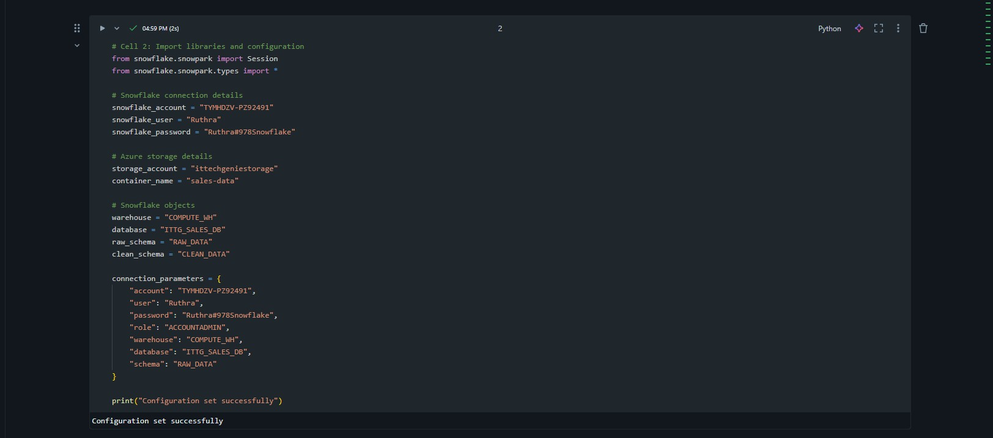

Step 3: Create Stage and File Format

session.sql("""
CREATE OR REPLACE FILE FORMAT csv_format
TYPE = 'CSV'
FIELD_DELIMITER = ','
SKIP_HEADER = 1
NULL_IF = ('NULL', 'null')
EMPTY_FIELD_AS_NULL = TRUE;
""").collect()
session.sql("""
CREATE OR REPLACE STAGE azure_stage
URL = 'azure://itgretailstorage.blob.core.windows.net/monthly-sales/'
CREDENTIALS = (AZURE_SAS_TOKEN = '<your-sas-token>')
FILE_FORMAT = csv_format;
""").collect()
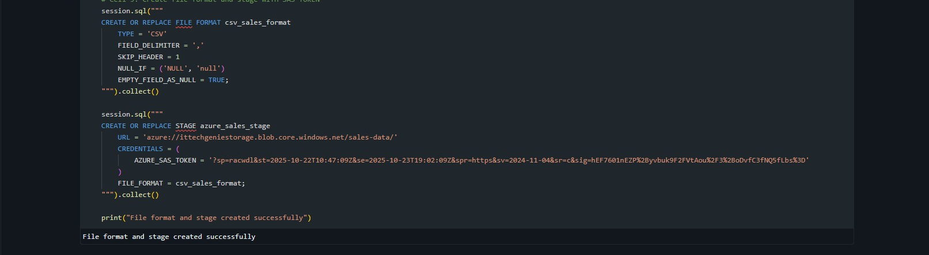

Step 4: Load Data into Snowflake

session.sql("""
COPY INTO raw_sales_data (
OrderID, OrderDate, MonthOfSale, CustomerID, CustomerName,
Country, Region, City, Category, Subcategory,
Quantity, Discount, Sales, Profit, FileName
)
FROM (
SELECT $1, $2, $3, $4, $5, $6, $7, $8, $9, $10,
$11, $12, $13, $14, METADATA$FILENAME
FROM @azure_stage/sales_october.csv
)
FILE_FORMAT = (FORMAT_NAME = csv_format)
ON_ERROR = 'CONTINUE';
""").collect()
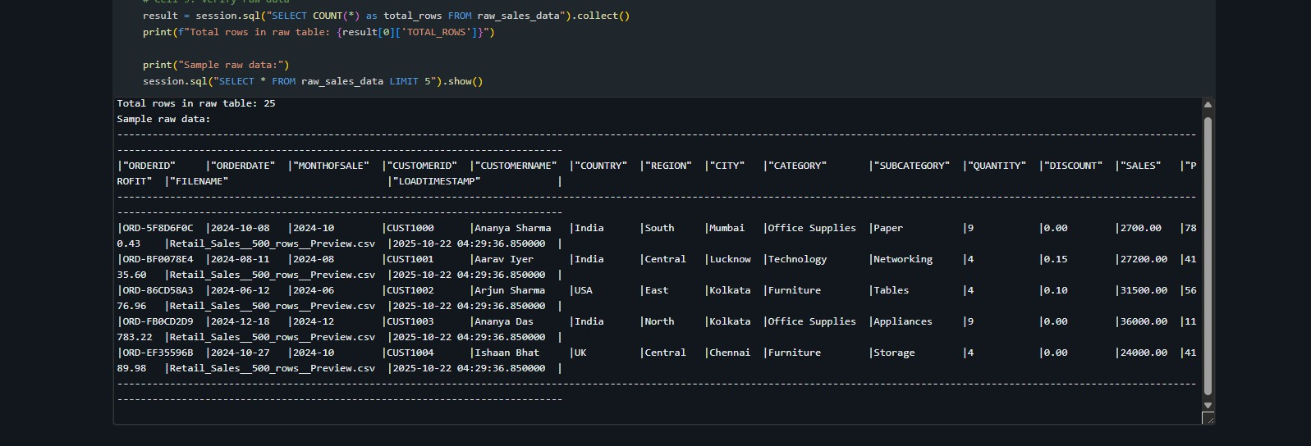

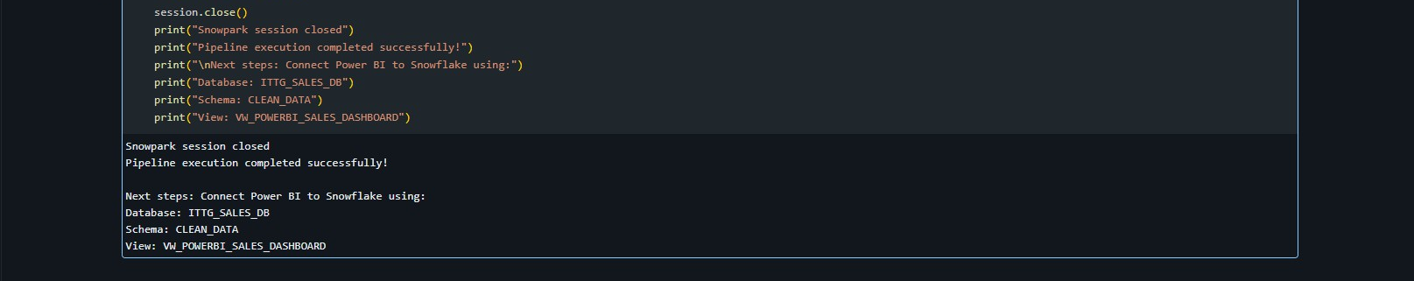

Phase 5: Power BI Reporting
- Open Power BI Desktop.
- Choose Snowflake as the data source.
- Connect using your Snowflake credentials and select the ITG_SALES_DB.REPORTING schema.
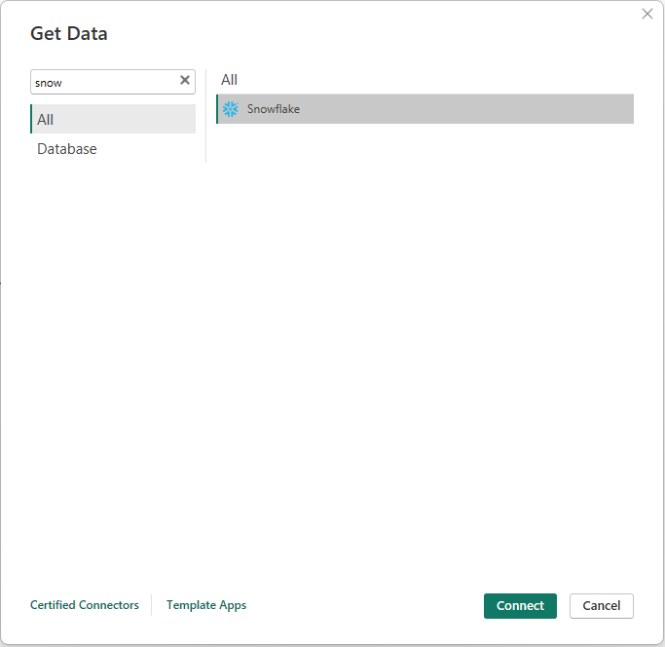
- Import Data
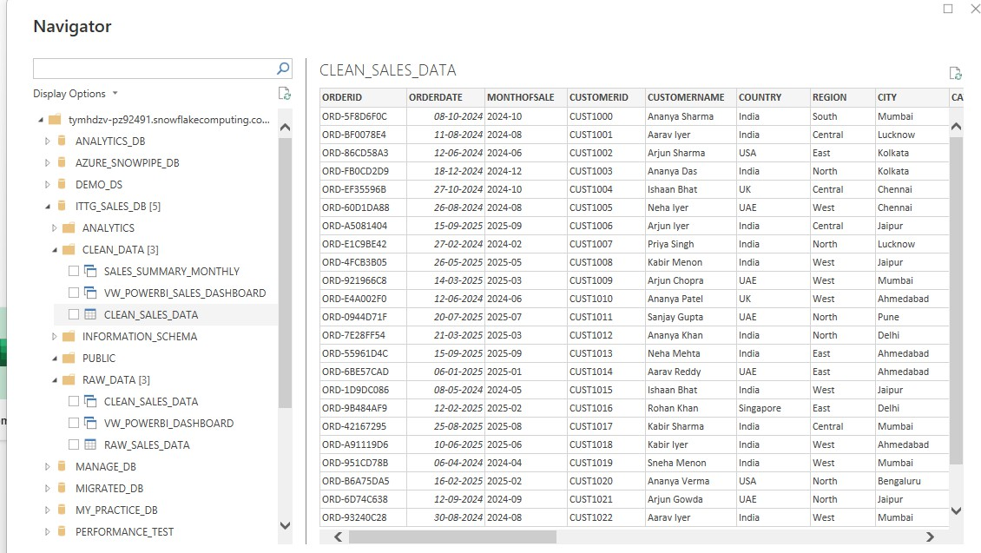
- Load the relevant tables or views.
- Build visualizations like:
- Monthly sales trends
- Top-selling categories
- Regional performance

